

The Youth Crew

Volunteering Project
Florina, Greece
June 2021 – November 2021

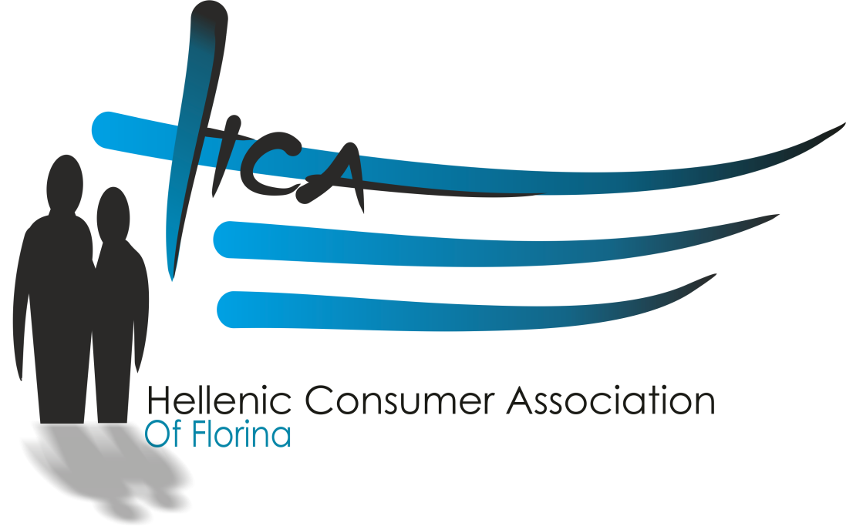

Dear volunteer!
We are Hellenic Consumer Association of Florina (EKATO), powered by Association of Active Youths of Florina, the hosting organization of “The Youth Crew” ESC Volunteering project. We assume you have a lot of questions, so we created this info pack with the help of other volunteers, to show you already how you will be living and also to support you in your first days here, to get to know the city of Florina.
We hope this pack is helpful for you and clears all doubts and questions. If that’s not the case, of course you are welcomed to ask us anytime

Short description of organization
EKATO is a Nonprofit – Nongovernmental organization with local and International activity. The aim of our organization is to empower citizens to be active in their local community and to participate in a wide range of activities such a voluntarism and democratic actions. The organization includes the fight against inequality and racism and the promotion of tolerance in our common European society.

About Florina
Florina is a small city in mountainous northwestern Macedonia, Greece. Florina is a market town with an economy dominated by agriculture, forestry, summer but mostly winter tourism, cross-border trading and the sale of local products such as grain, grapes, vegetables and the famous Florina peppers. It also has textile mills and is known for locally manufactured leather handicrafts. However, the most notable industrial activity is the very large Ptolemaida-Florina lignite mine, used in the lignite power plants which cover a large part of Greece’s electric power needs. Florina region in general offers great landscapes, with mountains, lakes, valleys, old forests, rivers and beautiful picturesque villages. The most popular places for daily excursions is the historic Nymfaion village, where the Environmental Centre ARCTUROS is offering shelter to brown bears from the close mountains; Amyntaio village which is surrounded by wineries that produce the famous Amyntaio Wines; and of course the Prespa twin lakes (with the large one being shared by Greece, Albania, and FYROMacedonia) which was recently added to UNESCO's World Network of Biosphere Reserves, with 11 native fish species and the perfect place for bird watching.
The city of Florina offers nice walks or bicycle rides with public bicycles provided by the municipality. There are many nice coffee-houses and restaurants in the pedestrian street in the city centre and by the river. As Greeks have their dinner quite late in the evening, it is easy to find something to eat even until late at night. You can always grab a souvlaki from the street, at all hours of the day.

What is a Volunteering Project in ESC?
The ESC Volunteering project provides young Europeans with the unique chance to express their personal commitment through unpaid and full-time voluntary activities in a foreign country within or outside the EU. In this way, it seeks to develop solidarity, mutual understanding and tolerance among young people, thus contributing to reinforcing social cohesion in the European Union and to promoting young people's active citizenship.
Open to all young people aged 18 to 30, ESC is a true ‘learning service’. Beyond benefiting the local communities, by participating in voluntary activities, young volunteers can develop new skills and, therefore, improve their personal, educational and professional development. Volunteers can benefit from specific training throughout the activity and agree on their expected learning outcomes, processes and methods in advance... Participation is free for the volunteers (except for a possible contribution of a maximum of 10% of the travel costs) who also get board and lodging, insurance cover and an allowance for the duration of the project.

What is not an ESC Volunteering Project:
- occasional, unstructured, part-time volunteering
- an internship in an enterprise
- a paid job; it must not replace paid jobs
- a recreation or tourist activity
- a language course
- exploitation of a cheap workforce

Project details
The Youth Crew (Youth CREativity Workshops) project aims to empower the local community and especially the youth of the city of Florina and the wider area. The short-term goals are to design and implement activities and workshops for volunteers to cultivate creativity and skills development of young people in the area. The long-term plan aims are allongiside with thw ESC priorities providing young people with opportunities to engage in solidarity actions that bring about positive social change while improving their skills and abilities for personal, educational, social, cultural and professional development. The plan also seeks to boost employability and facilitate the transition to the labor market, including by supporting the mobility of young volunteers, trainees and workers. The project, based on its structure as well as those involved, promotes social inclusion and equal opportunities, and in particular the participation of young people with fewer opportunities.
Providing opportunities for young people in remote Florina, as well as volunteers from Spain who are young people with fewer opportunities, is an action that promotes solidarity and addresses and strengthens all social and economic groups in the region. Providing training workshops and activities to young people who are not financially able to attend them for pay is a means of boosting some vulnerable social groups by promoting solidarity. Every effort is made to strengthen solidarity between people by respecting their cultures and traditions, and the aim is to build a community of shared responsibility and mutual support. Participants in the European Solidarity Corps, through the workshops they will carry out and the actions they will undertake and implement, will make a significant contribution to society by demonstrating solidarity, cooperation and mutual understanding and the learning outcomes for young people involved and their development. Volunteers during the The Youth Crew project will provide volunteer services in two main areas, the education and information sector and support EKATO activities, and will offer their voluntary services for 30-35 hours on a weekly basis.
The Youth Crew project foreign language learning laboratories and the learning of Greek by the volunteers. In addition, a workshop aimed at young people in the city is planned, aiming at organizing the various activities of the organization, as well as cultivating and reflecting young people on issues that concern them. In addition, in this workshop, young people will have the opportunity to spend their free time creatively, group and non-games organized by volunteers. Participants in the workshops and therefore in this project will be young people of all ages from the wider region of Western Macedonia. The number of participants will be between 100 and 150 people throughout the project. Priority will be given to vulnerable social groups, people with fewer opportunities, people out of education, training or work (NEETs). Then target group is students and students of the wider region of Florina.

Main objectives of the project
• To clarify the challenges of ESC among the two countries regarding to content and methodology, non-formal and informal learning process, inter cultural learning and impact on local community
• To raise awareness on key competences and develop different methods for using them in practice within ESC projects
• To experience being in position of volunteers and raise awareness on personal, social and professional development during ESC activity
• To make inter cultural exchange of art, culture, tradition and customs between the participating countries
• To raise the EU values of the municipalities and its citizens.
• To exchange good practices in the field of youth

Hosting organisation | Activitites Venue
Hellenic Consumer Association of Florina  Florina, Greece  https://ekatoflorinas.jimdosite.com/  ekatoflorinas2001@gmail.com  ESC Contact Person: Konstantinos Stergiou (stergioukon@gmail.com) | All activities will be carried out at:  Europe Direct Informatio Center (EDIC) of Western Macedonia, Florina, Greece  https://www.europedirect-oenef.eu/  www.oenef.eu

Division of rights and responsibilities among organisations and volunteer
Hosting Organisation  (EKATO) | - To ensure that the volunteer attends the full ESC Training and Evaluation Cycle, including the on-arrival training and the mid-term evaluation taking place in Greece  - To ensure, with the Sending Organisation, that volunteer is covered by the obligatory ESC group Cigna Insurance plan  - To ensure travel arrangements in cooperation with the Sending Organisation and the volunteer  - To Book travel cost from the home country to the host country to the volunteer  - To Book return Tickets from hosting country to home before two last month of project ending date.  - To identify a qualified mentor who is responsible for providing personal support to the volunteer.  - To provide suitable accommodation for the volunteer.  - To encourage contact with other ESC volunteers whenever possible  - To transfer to the volunteer monthly pocket money and food allowance in the beginning of the month.  - To arrange language learning opportunities through Online Linguistic Support Platform (ONLINE LANGUAGUE COURSE)  - To offer supervision and guidance to the volunteer through experienced staff and orientates the volunteer in the new working placement and duties after the arrival  - To provide personal support to the volunteer by well integrating the volunteer in the organisation.  - To cooperate with the project partners, including in conflict solving and crises management  - To offer to the volunteer the opportunity to carry out a well-defined set of tasks (allowing some of the volunteer’s ideas, creativity and experience to be integrated  - To support volunteer in filling the Youthpass certificate for those volunteer who want to recieve it at the end of their ESC Activity.  - Medical Support (if is it needed)  - Issuing the Youthpass for the volunteer
Sending Organisation | - To provide information about the ESC Programme a non-formal learning possibility (including the Youthpass)  - To ensure the participation of the volunteer in the pre-departure training course or organise preparation training/meeting for the volunteer  - To provide adequate preparation (cultural, language, task related) for the volunteer before departure, according to the individual needs of the volunteer  - To inform the volunteer about the ESC group Insurance plan foreseen in the Erasmus+ Programme and gives all necessary information to the volunteer about the CIGNA procedures  - in case the volunteer cancels his/her participation in the ESC project, the Sending Organisation has to send an official cancellation letter (stating mentioning the reason of the cancellation, the volunteer´s signature and the date) to the Hosting Organisation and identify new volunteer applicants  - To keep in contact with the volunteer and the Hosting Organisation during the whole project  - To ensure the participation of the volunteer in the evaluation of the Activity  - To give the volunteer the opportunity to exchange and share experiences and encourages the involvement of the volunteer in dissemination and exploitation of results  - To provide guidance regarding further education, training or employment opportunities  - To support the travel of the volunteer to the host country.  - To cover from, preparation costs and organization budget, overcosts or damages that volunteer will not cover make during the project, or flight cancelations.
Volunteer | - To be actively involved in the preparation and evaluation phases of the activity  - To attend all trainings and information sessions related with the project, before, during and after the ESC placement  - To read and understand the “Activity Agreement” and “ESC Charter” documents  - To show commitment to the Sending and the Host organisation and the ESC programme  - To be actively engaged in dialogue with the Host organisation, especially with his/her Project Coordinator and his/her Mentor  - To expresse any concerns, problems or suggestions for improvements  - To carry out dissemination and exploitation activities together in cooperation with the host organisation as planned in the application and agreed during the activity and write the Final Report and the Youthpass in the end of the Project  - Participate actively in the monthly evaluation meetings held by the Hosting Organisation or Coordinating if Hosting can not offer.  - To cover over budget of travel costs from the home country to the host country,  - To conclude and sign final report and docs needed before departure to home.  - Accommodation: to respect the neighbours and the living conditions in the apartment. To take financial responsibility in case of any major damage done in the apartment.  - To send a monthly report to sending organization about his/her project life.

Role and tasks of the volunteer
Volunteers will participate in different activities:
- Promotion of intercultural participation and learning. We manage an information desk in Florina in which local youth are informed about European mobility programmes. Volunteers may help giving information and counselling.
- We also help and advise other organisations to develop European programmes. Volunteers also participate.
- We also organise seminars and information sessions related with Europe, European Citizenship, as well as other more informal activities (cinema forum, multicultural meetings,...) in which we diffuse information about the EU, intercultural values and participation. In this campaigns, volunteers may present their European citizenship experience.
- We also participate in and organise other mobility activities, so the groups receive pre-departure training with the aim of giving more value to their multicultural experience, so in this training process, ESC volunteers may talk about their experience of living in another culture and country and contribute to their preparation.
- Campaigns of promotion of volunteering. We organise workshops and training seminars at a local and regional scale. Volunteers may collaborate with these activities with the training team in the whole process: contact with organisations, planning training sessions, development and evaluation of sessions and they may also form active part of them if they want to talk about their experience as a volunteer.
- Youth Information. Volunteers will search, select and diffuse local, regional and national youth information with the mentor through the organisation's web site and other social media.
- Youth Information field on website, facebook, e-newsletter, blog update
- Creation of a touristic brocure of the city of Florina promoting its natural beauty and the opportunities for a visitor
- Volunteers will also learn Greek language, as this is will also be our working language together with English.
- Flexible zone, will give free space and the opportunity to volunteers to organize and develop their own projects in local or international level.
- Radio show every week at the local radio station
- Local activities run by EKATO in cooperation with the municipality of Florina, schools and other bodies working on the youth sector.
- Volunteers will have a mentor for all these activities
- Volunteers will support the Europe Direct Information Center (EDIC) hosted in the offices of Active Youths of Florina.

Practical arrangements

Budget policy
Each volunteer will be receiving 120 euros for food and 150 euros for pocket money (In total 270 euros per month) at the beginning week of every month.

Travel costs
According to ESC regulation (maximun budget available) is 360 euros for the travel cost to at the beginning and after the end of the project. The booking of the ticktets will be done only from the Hosting organisation(EKATO).

Food
Volunteers could cook their meals by their own in their flats as they are going to receive 100 euros each month to buy goods from local markets. Markets in Florina are really cheep.

Language Course
For the Greek courses, a class has been formed just for this need and the volunteers are having 2-hours per week class.

Insurance
The participants have private insurance by CIGNA, which covers all their needs for the whole duration of their project and even after that (for a few months). We already have created a network of doctors and hospitals for all their needs, so we can immediately serve their needs, even the most emergent.

Daily work
The volunteers’ working hours will be in on from 10:00 to 15:00 from Monday to Friday. Occasionally some afternoons from 18:00 to 20:00 depending on the events running. Every Friday there is a meeting with the coordinator and the mentor, to check the working plan of the previous week and schedule the working plan of next week.

Days off
The participants have 12 working days free (2 days per month), apart from the national and religion official holidays of Greece. If they work hard on their tasks, the mentor and the coordinator may give them more days off, as a reward.

Hosting conditions
The volunteers will be living in an a fully equipped apartment in the city of Florina.
Heating, electricity, water and internet will be covered by the hosting organization.
See annex for flat rules.
Every 20 days a cleaning lady will visit the house to make sure the conditions of living are always at a high level. Moreover, the ESC coordinator will visit the house each week in order to check for any needs or problems

Phone
Volunteers will be provided with a Greek SIM card for national calls and SMS.

Local transport
Both participants will have their personal bike. Volunteers are not getting extra money for their transportation, since all distances in Florina can be done on foot. In cases that they need to travel for the project’s needs, EKATO will cover all related costs.

The principles that we want to share
We would like to work with responsible, flexible, patient, tolerant, comprehensive, empathetic, mature, humble and funny young people interested in learning, working and living 120% in an ESC project.
We are totally open to receive, requests or suggestions when something is not working in and we will work to solve it as soon as possible.

EKATO

Konstantinos Stergiou

ESC Coordinator

This info pack was made with the contribution of our partners
Asociación Juvenil INTERCAMBIA, Málaga , Spain  www.europaerestu.eu | United Societies of Balkans, Thessaloniki, Greece  www.usbngo.gr

ANNEX

General flat rules
- If the volunteer loses a key of the flat, he/she needs to pay to make a new one.
- Ensure that you switch off all the lights and electrical items and turn off the water when you leave the house every day.
- Apartment will be checked once in a month to ensure that the house rules are being adhered to.
- All rooms and equipment must be kept clean and tidy and any breakages must be reported immediately to the ESC Coordinator.
- Any damage caused to either the room or the common areas will be paid for by the volunteer who is responsible for it.
- No smoking inside the building. You can smoke out in the garden.
- No loud noise before 8 am in the morning and after 11:45 pm in the evening. Failure to abide by this rule may make the neighbors call the police.
- Have respect for your flat mates and keep the common areas clean and tidy.
- There is a maximum cost of water and electricity per month and per volunteer, estimated on 25 euros each person. If the real costs are over this rate, the additional sum will be covered by all the volunteers of the flat, as we cannot calculate each person’s consume. We kindly ask for cooperation in order to avoid conflicts on this topic.
- Animals are not permitted in the rented property without written agreement from the landlord.
- The volunteer will inform the hosting organization in writing as soon as possible about any damage or loss that requires a repair to be carried out.
- The hosting organization deserves the right to move the volunteer to another flat in case it is needed, he/she will be informed at least 15 days earlier.
- Each volunteer may have guests in the flat, but with the following conditions:
- The other flat mates are notified and have accepted this.
- The guests can stay no longer than a week and they need to follow the general flat rules.
- There can only be one guest at a time.

Next to these general rules you can also set your own internal rules (like room rotations, room access, music time, guests, cleaning timetables…), however, we cannot take responsibility of them.

Land lord obligations
In case you need something from the landlord, you can contact him through EKATO.
- Technical maintenance and repairs are the responsibility of the landlord. The landlord agrees to carry out the repairs as quickly as possible.
- The landlord may not carry out any renovations or alterations to the rented property without written consent from one of the volunteer and may never carry out such work during the revision and examination period.
- The requested renovations or alterations must be clearly defined. The volunteer may not make any alterations to the rented property without written permission from the landlord.
- The landlord agrees to ensure the peaceful enjoyment of the room. S/he is only able to gain access to the room in the event of force majeure or after volunteer notification.
- Both parties or third parties to whom access has been granted, must refrain from activities that may disturb the peace of residents or neighbors.
- Both parties agree to submit all disputes arising from the interpretation, compliance with or the termination of this agreement to the Housing Service, before bringing the matter to court so that the Housing Service is able to make a proposal for reconciliation. The initiative for taking any legal steps rests with the parties themselves.

Failure to abide by these rules may result in you being asked to the leave the flat.

This rate is 150% of the monthly average costs of the year before.

